Jessica Gerschultz

802 words

**Farhat, Safia (b. 1924 Radès, Tunisia—d. 2004 Radès, Tunisia)**

Safia Foudhaïli Farhat (b. 1924 Radès, Tunisia—d. 2004 Radès, Tunisia)was a Tunisian artist, arts administrator, and teacher. She was among the few elite Tunisian girls to receive a primary and secondary education in schools of the French Protectorate. In 1952 she was the third female Tunisian student to graduate from the colonial École des Beaux-Arts in Tunis. After independence in 1956, Farhat became the first Tunisian woman to teach at the *Beaux-Arts*, where she directed the atelier of decoration from 1958 until 1966. Along with Abdelaziz Gorgi, she was instrumental in launching an arts curriculum aligned with government initiatives for national development. Specifically, she partnered with the *Office Nationale de l’Artisanat* to revitalize artistic heritage and modernize local industries. She is credited with formally training the first generation of female art students, and was an influence on fiber artists such as Fatma Samet and Mohamed Njeh. In 1964 and 1966 Farhat was promoted to assistant director and director respectively, thus becoming the first Tunisian to head the École des Beaux-Arts. She held this position until 1973, the same year she engineered the joining of the art school (thereafter called the Institut Technologique d’Art d’Architecture et d’Urbanisme or ITAAUT) with the national university system.

Farhat is best known in Tunisia for her artistic projects of the late nationalist and early postcolonial periods. 1n 1960, she joined as the only female artist in the École de Tunis (formed in 1948), an elite group that sought to create an artistic modernism rooted in the concept of *tunisianité*, or Tunisian cultural patrimony. Like her colleagues, Farhat was trained as a painter and produced many two-dimensional works on paper and canvas in her lifetime. In addition, she designed dozens of monumental works in various media associated with local artistic traditions: weavings, ceramic tile panels, and low-relief sculptures in ironwork and stone. Farhat secured government commissions for decorative programs in 1963 when she co-founded the Société Zin with Abdelaziz Gorgi. This enterprise capitalized on the reinstated “1% law”, which mandated that one percent of a civic building’s budget be designated for its decoration with modern art. She installed notable works in buildings designed by architect Olivier-Clément Cacoub. Farhat’s success with the Société Zin led her to establish a weaving studio on her property in Radès. Her monumental tapestries, woven in locally produced wools, are her signature artworks and hang in banks, hotels, refineries, and other government offices. Two of the most significant tapestries hang in the Central Bank in Tunis. While the themes, materials, and motifs of her artistic corpus vary, much of her work embeds a gendered subjectivity. Farhat drew from the materials and woven iconography of women from the southern interior, interpreted local iterations of the epic of Ulysses and Penelope, and created countless profiles of idyllic female figures.

Fig a

Farhat is associated with the social reforms and government of the first president Habib Bourguiba because of her gender and her marriage to Abdallah Farhat, a prominent minister. In 1959 she founded *Faïza*, the first postcolonial women’s journal in Tunisia, which she directed until 1966. *Faïza* is an important source on the development of Tunisian artistic modernism and on Bourguibism more generally. As much as Farhat contributed to nationalist discourses, however, she engaged with global art networks throughout her career, particularly those of the French tapestry and New Tapestry movements. Until she retired in 1981, Farhat worked in ITAAUT in various leadership capacities. In the same year, she and Abdallah Farhat opened a private art school on their property, the Centre des Arts Vivants de Radès, which she directed until 2000. 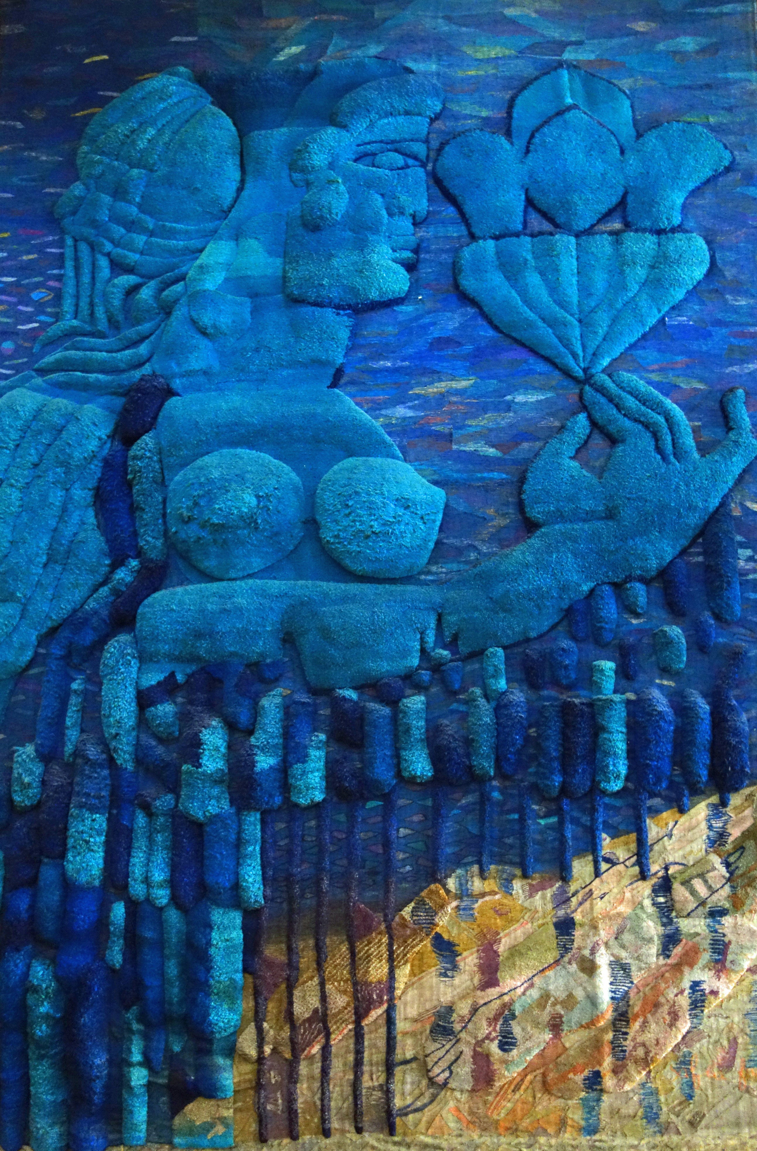

Safia Farhat, Untitled, Tapestry in the Banque Centrale, 1978

**References and further reading**:

Ben Rhomdane, N. (2002) *Les pionniers de la peinture en Tunisie*, Tunis: Ministère de la Culture.

Bouzid, D. (1995) *École de Tunis*, Tunis: Alif- Les Editions de la Méditerranée.

Filali, A. (2005) *Safia Farhat: Une Biographie*, Tunis: MIM Editions.

Filali, A. (2009) ‘Historique de l’enseignement des Beaux Arts en Tunisia’, in *2009 Marid al Amal Taliba al Mahid/Exposition des travaux des étudiants*, unpaginated.

Gerschultz, J. (2014) ‘The Interwoven Ideologies of Art and Artisanal Education in Postcolonial Tunis’, *Critical Interventions: Journal of African Art History and Visual Culture*, forthcoming.

Louati, A. (1997) *L’aventure de l’art moderne en Tunisie*, Tunis: Simpact Editions.

Micaud, E. (1968) ‘Trois Decades d’art Tunisien’, *African Arts* 1(3): 46-55+78-84.

Triki, R. (undated) *Les femmes peintres dans la Tunisie moderne*, Tunis: Ministry of Culture, unpaginated.

List of Works:

Farhat, S. (1959) ‘De la Méditerranée au pays céleste’, *Faïza* 3: 56-61.

Farhat, S. and Filali, S. (1959) ‘Deux témoins racontent les derniers moments de Farhat Hached’, *Faïza* 4: 41.

Farhat, S. (1960) ‘Safia Farhat a fait un beau voyage’, *Faïza* 7: 24-29.

Farhat, S. (1962) ‘Enquête: La Tunisienne et l’enseignement. Ce mois-ci: De la Dar Moallama au Collège Moyen Féminin’, *Faïza* 21: 18-21.

Farhat, S. (1963) ‘Le Congrès de la Maturité’, *Faïza* 31: 24-27.